Epsom & Ewell
15
v
Eversley & California
Saturday, 29th December 2018 – 3.00 p.m.
Good afternoon! We welcome the players, supporters and officials of Eversley & California to High Road for an important League match. Our opponents defeated us 2-1 on our first visit to Fox Lane five weeks ago today and it must be admitted were full value for the victory. We have to redress the balance today if we are to keep up with the top clubs.

We were last here three weeks ago when we hosted Bedfont & Feltham and an exciting and entertaining match ensued in horrible conditions. I thought we were good value for a win but unfortunately a 90th minute equaliser from the visitors earned them a point from a 4-4 draw.

A friendly at Chipstead was postponed on Tuesday 18th December as was our trip to Sheerwater, following the decision by their landlords Woking FC to postpone the match a few days early. We await the League decision on this, as the postponement was in breach of League rules, coming three days before the match was due to be played. We’ll advise more when we know.

We visit Cove next Saturday before returning here two weeks today for the visit of Ash United and then have two further home matches in quick succession as we host Godalming Town in the League Cup on the Tuesday 15th before hosting Bagshot on Saturday 19th January.

Our club regrets to announce that our former Manager Peter Norris has passed away at the age of 78. He was in charge of the club from the summer of 1969 until October 1971 and had been a former P.E. teacher at Glyn School where many will remember him from. He was living in Ewell Village at the time of his passing and we will be holding a minute’s silence at this afternoon’s game in his memory.

We have plenty to look forward to in 2019 with participation in three cups, and are not out of the promotion race in the League yet, while we are hoping to hear some good news shortly on a new ground. We also have many matches and players available for sponsorship, just ask a Committee member for details.

All that remains to be said today is that the club wishes all of its supporters, players and Management a Happy New Year!

Enjoy the game!

Rich

You can follow us on Facebook: www.facebook.com/epsomandewellfc
Twitter: @EEFCOfficial Instagram at: www.instagram.com/epsomandewellfc
and Youtube at: www.youtube.com/channel/UCtLrpS0x5OaYUACRT34_zng

Cover photo by Gemma Jarman

Liam Roberts scores our third goal against Bedfont & Feltham on 8th December

Cherry Red Records Combined Counties League
Division One Table 2018/19
inc Saturday 22nd December 2018 | P | W | D | L | F | A | Pts | GD | H | A
Frimley Green | 20 | 13 | 5 | 2 | 39 | 25 | 44 | +14 | 3-0 | 23/2
Bedfont & Feltham | 18 | 13 | 4 | 1 | 62 | 19 | 43 | +43 | 4-4 | 13/4
Sheerwater | 18 | 12 | 3 | 3 | 44 | 25 | 39 | +19 | 2-3 | ???
Epsom & Ewell | 19 | 11 | 2 | 6 | 47 | 33 | 35 | +14 | X | X
Tooting Bec | 18 | 10 | 3 | 5 | 40 | 25 | 33 | +15 | 3-1 | 30/3
Dorking Wanderers Res | 22 | 10 | 3 | 9 | 51 | 50 | 33 | +1 | 3-0 | 3-5
Farnham Town | 15 | 9 | 4 | 2 | 33 | 13 | 31 | +20 | 2/2 | 1-4
Ash United | 19 | 9 | 4 | 6 | 50 | 40 | 31 | +10 | 12/1 | 2-1
Sandhurst Town | 17 | 9 | 3 | 5 | 28 | 29 | 30 | -1 | 20/4 | 2-0
British Airways | 20 | 8 | 4 | 8 | 44 | 44 | 28 | 0 | 16/2 | 2-3
Chessington & Hook Utd | 18 | 8 | 3 | 7 | 34 | 34 | 27 | 0 | 1-2 | 4-1
Bagshot | 22 | 6 | 3 | 13 | 27 | 66 | 21 | -39 | 19/1 | 3-0
Eversley & California | 16 | 5 | 1 | 10 | 33 | 40 | 16 | -7 | 29/12 | 1-2
Godalming Town | 17 | 4 | 3 | 10 | 24 | 38 | 15 | -14 | 3-2 | 26/1
FC Deportivo Galicia | 18 | 3 | 3 | 12 | 27 | 35 | 12 | -8 | 12/3 | 3-0
Kensington Borough | 18 | 3 | 3 | 12 | 25 | 48 | 12 | -23 | 1-1 | 9/3
Fleet Spurs | 19 | 4 | 0 | 15 | 27 | 49 | 9 | -22 | 6/4 | 3-2
Cove | 16 | 2 | 1 | 13 | 18 | 38 | 7 | -20 | 3-2 | 5/1

AC London (removed) | 15 | 9 | 2 | 4 | 36 | 25 | 29 | +11 | - | 6-0

Lucky Day? – 29th December
Played 8 - Won 5 Drawn 1 Lost 2 - For 21 Against 9 - PPG 2.00 - Very Good
Our Club record against Eversley & California
Played 1 - Won 0 Drawn 0 Lost 1 - For 1 Against 2 - PPG 0.00
Eversley & California‘s last visit
This is their first visit

First Eleven Appearances 2018/19 - (max 28)
Name | Debut | 2018/19 |  |  |  | Career Totals
 |  | App | Sub | Tot | Goals | App | Sub | Tot | Goals
BENNETT Bobby | 12/08/2018 | 22 | 0 | 22 | 16 | 22 | 0 | 22 | 16
BETANCOURT Steve* | 18/08/2018 | 21 | 1 | 22 | 1 | 21 | 1 | 22 | 1
BORRETT Ricky | 04/08/2018 | 9 | 0 | 9 | 0 | 9 | 0 | 9 | 0
CAMPBELL Kieran* | 29/09/2012 | 7 | 3 | 10 | 2 | 59 | 3 | 62 | 2
CAMPBELL Theo* | 28/08/2018 | 2 | 9 | 11 | 1 | 2 | 9 | 11 | 1
CAULCRICK Joshua | 17/02/2018 | 0 | 4 | 4 | 0 | 0 | 5 | 5 | 0
CHIN Louis | 08/12/2018 | 1 | 0 | 1 | 0 | 1 | 0 | 1 | 0
CONNELLY Lloyd | 14/10/2017 | 28 | 0 | 8 | 4 | 58 | 4 | 62 | 6
DOBRAJ Endrit* | 18/11/2017 | 5 | 2 | 7 | 1 | 24 | 6 | 30 | 1
DYSON Ben* | 12/08/2017 | 0 | 1 | 1 | 0 | 28 | 14 | 42 | 2
ELGAR Luke | 04/08/2018 | 8 | 3 | 11 | 1 | 8 | 3 | 11 | 1
ELGAR Scott* | 12/08/2018 | 4 | 9 | 13 | 0 | 4 | 9 | 13 | 0
GAFFNEY Luke * | 16/08/2014 | 2 | 2 | 4 | 0 | 12 | 3 | 15 | 0
GAYLE Roy | 06/11/2018 | 3 | 0 | 3 | 0 | 3 | 0 | 3 | 0
GILL George* | 28/08/2018 | 2 | 0 | 2 | 0 | 2 | 0 | 2 | 0
GRIFFIN Reisse | 08/08/2015 | 16 | 0 | 16 | 2 | 120 | 13 | 133 | 10
GRIFFITHS Hakim | 08/12/2018 | 1 | 0 | 1 | 1 | 1 | 0 | 1 | 1
HEAGNEY Adam | 16/08/2016 | 28 | 0 | 28 | 1 | 95 | 13 | 108 | 3
HENDRY Rob | 08/08/2015 | 12 | 0 | 12 | 9 | 96 | 23 | 119 | 37
JEANNOEL Germaine | 02/12/2017 | 0 | 10 | 10 | 2 | 2 | 17 | 19 | 3
JONES David | 31/08/2018 | 6 | 2 | 8 | 0 | 6 | 2 | 8 | 0
LOFTUS-CHEEK Joe | 06/08/2017 | 0 | 1 | 1 | 0 | 14 | 8 | 22 | 6
MARTINEZ Olly | 29/09/2018 | 7 | 3 | 10 | 2 | 7 | 3 | 10 | 2
MCKAY Alex | 20/12/2008 | 1 | 0 | 1 | 0 | 163 | 39 | 202 | 13
MORGAN Sam | 11/09/2018 | 2 | 4 | 6 | 0 | 2 | 4 | 6 | 0
MURPHY Scott | 20/01/2007 | 24 | 0 | 24 | 3 | 71 | 2 | 73 | 7
MURPHY Todd | 27/11/2018 | 1 | 2 | 3 | 0 | 1 | 2 | 3 | 0
ROBERTS Liam | 12/08/2017 | 20 | 2 | 22 | 11 | 41 | 16 | 57 | 16
SMITH Taryn | 28/10/2017 | 6 | 6 | 12 | 5 | 14 | 10 | 24 | 5
SULLIVAN Ryan | 04/08/2018 | 17 | 1 | 18 | 0 | 17 | 1 | 18 | 0
SUTHERLAND Mitchel | 04/08/2018 | 1 | 1 | 2 | 0 | 1 | 1 | 2 | 0
THOMPSON Elliott | 09/02/2016 | 17 | 3 | 20 | 1 | 27 | 12 | 39 | 2
WATTS Jamie | 03/11/2018 | 6 | 0 | 6 | 1 | 6 | 0 | 6 | 1
WHITE Sean | 02/08/2014 | 9 | 4 | 13 | 4 | 29 | 25 | 54 | 9
WOODCOCK Josh | 22/09/2018 | 1 | 0 | 1 | 0 | 1 | 0 | 1 | 0
WRIGHT Kieran* | 15/09/2018 | 3 | 3 | 6 | 0 | 3 | 3 | 6 | 0
YOUNG Conor | 07/03/2015 | 16 | 0 | 16 | 0 | 49 | 0 | 49 | 0
* - Player has left the club

Recent Results and Fixtures
Combined Counties League – Saturday 8th December
British Airways | 3-1 | Kensington Borough
Dorking Wanderers Reserves | 0-5 | Tooting Bec
Epsom & Ewell | 4-4 | Bedfont & Feltham
Eversley & California | 1-2 | Ash United
FC Deportivo Galicia | 3-1 | Chessington & Hook United
Frimley Green | 2-1 | Fleet Spurs
Godalming Town | 2-1 | Sandhurst Town
Sheerwater | 4-2 | Bagshot
Combined Counties League – Tuesday 11th December
Cove | 0-1 | Bagshot
Combined Counties League – Saturday 15th December
Ash United | 1A1 | Godalming Town
abandoned after 74 minutes – torrential rain
Bagshot | 1-3 | Fleet Spurs
Bedfont & Feltham | 2-1 | Eversley & California
Chessington & Hook United | 3-1 | Dorking Wanderers Reserves
Farnham Town | 1A2 | Cove
abandoned after 60 minutes – torrential rain
Kensington Borough | 0-3 | Sheerwater
Combined Counties League – Saturday 22nd December
Bagshot | 3-3 | Tooting Bec
British Airways | 2-2 | Chessington & Hook United
Cove | 1-2 | Frimley Green
Dorking Wanderers Reserves | 4-3 | Godalming Town
Eversley & California | p-p | Sandhurst Town
FC Deportivo Galicia | 1-3 | Bedfont & Feltham
Fleet Spurs | 1-4 | Ash United
Sheerwater | p-p | Epsom & Ewell
Combined Counties League – Saturday 29th December
Ash United | V | Farnham Town
Epsom & Ewell | V | Eversley & California
Kensington Borough | V | Dorking Wanderers Reserves
Sandhurst Town | V | Cove
Sheerwater | V | Chessington & Hook United
Recent Results and Fixtures
Combined Counties League – Saturday 5th January 2019
Bedfont & Feltham | V | Sheerwater
Chessington & Hook United | V | Frimley Green
Cove | V | Epsom & Ewell
Eversley & California | V | Tooting Bec
Farnham Town | V | Kensington Borough
FC Deportivo Galicia | V | Ash United
Godalming Town | V | Bagshot
Combined Counties League – Saturday 12th January 2019
Bagshot | V | Bedfont & Feltham
British Airways | V | Farnham Town
Cove | V | Fleet Spurs
Dorking Wanderers Reserves | V | Eversley & California
Epsom & Ewell | V | Ash United
Frimley Green | V | Sandhurst Town
Sheerwater | V | Godalming Town
Tooting Bec | V | Chessington & Hook United

Surrey Premier Cup
First Round
Carshalton Athletic U19 | w/o Ash | Ash United
Shene Old Grammarians | 2-4 | Old Wilsonians
Lingfield | 5-1 | Horley Town Reserves
Alfold | 2-0 | Godalming Town
Epsom & Ewell | 5-0 | Knaphill U23
Reigatians | 0-4 | Frimley Green
Met Police Reserves | 3-3 | FC Deportivo Galicia
Met Police Reserves win 5-4 on penalties
Second Round
Ash United | 3-1 | Chessington & Hook United
Alfold | 0-1 | Nottsborough (holders)
Old Wilsonians | 1-6 | Lingfield
Sheerwater | 5-0 | Corinthian Casuals Reserves
Farnham Town | 4-1 | Westfield Reserves
Epsom & Ewell | 4-0 | Dorkinian
Met Police Reserves | V | Dorking Wanderers Reserves
Bagshot | V | Frimley Green

This Day in History - 29th December
Date | Day | Competition |  | Opponents |  | Scorers
29/12/34 | Sat | London League | H | Eton Manor | 5-1 | H.Pullen (3), J.Jones (2)
29/12/45 | Sat | Friendly | H | Carshalton Athletic | 7-0 | G.Brogdale (4), K.Minter (2), K.Holliday
29/12/51 | Sat | Surrey Senior Cup 1 | H | Dulwich Hamlet | 2-4 | B.Goddard, T.Wright
29/12/56 | Sat | Corinthian League | H | Maidenhead United | 2-1 | J.Bangs (2)
29/12/73 | Sat | Surrey Senior League | A | Horley Town | 1-0 | D.Ritman
29/12/84 | Sat | Isthmian League Premier Division | A | Croydon | 1-2 | S.Hill
29/12/90 | Sat | Isthmian League 2s | H | Harefield United | 2-0 | S.Barwick, D.Fry
29/12/01 | Sat | Isthmian League 3 | A | Egham Town | 1-1 | J.Rogers
Historical Decades
Date | Day | Competition |  | Opponents |  | Scorers
90 years ago – Epsom Town F.C.
26/12/28 | Wed | London League | H | Finchley | 3-2 | G.Carmichael, J.Parr, W.Challis
80 years ago – Epsom F.C.
17/12/38 | Sat | London League | H | Bostall Heath | 5-5 | F.Stenning (3), J.Jones, B.Evans
70 years ago – Epsom F.C.
27/12/48 | Mon | Friendly | H | Guildford | 1-0 | J.Emblem
60 years ago – Epsom F.C.
27/12/58 | Sat | Corinthian League | A | Horsham | 1-5 | R.Carter
50 years ago – Epsom & Ewell F.C.
26/12/68 | Thur | Athenian League 2 | A | Worthing | 1-5 | A.Thompson
40 years ago – Epsom & Ewell F.C.
30/12/78 | Sat | Surrey Senior Cup 1 | H | Egham Town | 0-1
30 years ago – Epsom & Ewell F.C.
27/12/88 | Tue | Isthmian League 2s | H | Banstead Athletic | 3-0 | B.Perkins, Williams, C.Hadingham
20 years ago – Epsom & Ewell F.C.
28/12/98 | Mon | Isthmian League 3 | A | Dorking | 2-2 | J.Holman, J.Tome
10 years ago – Epsom & Ewell F.C.
27/12/08 | Sat | Combined Counties Premier Division | A | Banstead Athletic | 5-0 | K.Hough (2), S.Sinclair (2), L.White

History Corner – 29th December
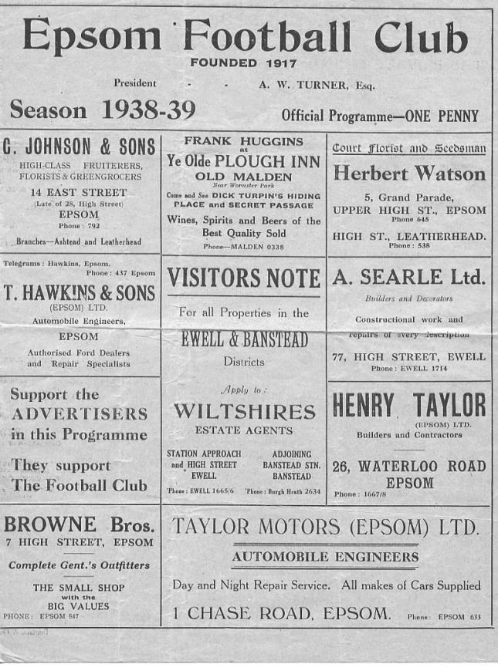
84 years ago today we hosted Eton Manor in a London League match. They were a new addition to the League ranks and in their first season would finish third from bottom, although would become Champions a few years later. Right now though, they weren’t up with the top teams, of which we were one and we crushed them 5-1 at West Street with Jackie Pullen scoring a hat trick; his third in seven days, giving him ten goals in his opening four matches since joining from Tooting & Mitcham United where he had also been successful. However, a very weak Epsom side travelled there at the end of the season where the Essex side got their revenge with a 6-1 win.

80 years ago this week the single most bizarre result in club history occurred. Epsom were coasting to victory over Kent side Bostall Heath in a London League match, and led 5-0 at half time with Fred Stenning already having scored three. The supporters were no doubt discussing whether they could get ten. Well, we saw ten goals alright, but all ten were at the same end as the visitors scored two quick goals and grew in belief from there, eventually drawing 5-5!! (see programme pictured)

73 years ago today we defeated our local rivals Carshalton Athletic 7-0 in a friendly at West Street. Gordon Brogdale scored four of the goals, while youngster Kenny Minter got two and Ken Holliday got the other one. Holliday was an interesting person who played with three German bullets in his chest from war time action! His father had played briefly for us in the twenties but it was his brother Charlie who would become best known. He also played for us briefly before going on to become a top level Linesman, officiating in the top flight of professional English football and also at a European Cup tie between Real Madrid and Barcelona in 1960. He would also referee our trial matches in the late fifties at no charge, although his own personal records show that he never refereed in the Football League, remaining a Linesman to the end!

Centre page for results

Centre page for results

Eversley & California – History
Eversley FC was originally formed in 1910 but returned to play in Eversley Village in 2008. Eversley FC were founder members of the Surrey Elite Intermediate League and the Boars became Champions in Season 2008-09 (on goal difference). The following season Eversley joined the Combined Counties League Division 1, for first three seasons finishing mid table.

California Youth Football Club was formed in 1975 when a group of parents brought together an Under 8’s team based in the California area of Wokingham, Berkshire and from where the Club takes its name. The Club now is providing foundation and youth football for all age groups, and expanded to become one of the largest youth soccer clubs in the area. In the year 2000 it was the first Berks & Bucks FA affiliated club in the area to be awarded the FA Charter status, also winning the South of England FA Charter Merit Award in 2002; it is currently an FA Charter Development Club.

California Youth FC established strong links with Eversley FC with the two clubs merged in 2012 to form Eversley & California Football Club and moving to the Boars Den, where we play our games today.

Playing in the CCL in recent times as shown the Boars have consistently finishing in the top half of the division, only missing out on promotion by only a few points in seasons 2014-15 & 2016-17. The season 2012-13 we finished in 2nd but could not go up due to ground grading.

The new era under our Chairman & Exec Committee, has brought in a Reserves / Development side who are playing in the highly rated Suburban League in 2017/2018. Plus, by creating a training program which includes the youth team players from under 16 in to Seniors it allows a clear pathway to allow all to play in the same way with the coaching coming from the group of coaches who now are implementing that training plan.

The extended ground improvements which have been completed in the last two years, enabled our first team to enter the FA Cup 2017-18 season for the first time in our history, unfortunately falling at the first hurdle.

The Club now operates a structure for progression for youth players in the local community from soccer school from the very young, through from Under 7’s up to and including Under 18’s, which is a true player pathway into Senior men’s teams. Today we are already seeing several young players who joined the club at 6 years old, now playing regularly in our First & Development Teams.

The Boars now are also providing football coaching and matches for all abilities over the weekend at our ESA sports grounds. The Club runs an annual tournament supported by teams from far afield, soccer camps and specialist coaching courses throughout the year.

Previous Managers
In our latest instalment we cover the fairly depressing period from 1966 to 1969.

Tony Williams – October 1966 – August 1967
Dave Fillery - August 1967– May 1969

The sudden departure of Jimmy Smith in September 1966 through ill health, left us with a Caretaker Manager in place by the name of Bill Budd who was officially Assistant Secretary to Robert Bell. This couldn’t continue for long though and in October we appointed Tony Williams; a former player with Corinthian Casuals, Kingstonian, Redhill, Bedford and Hereford. He was born in Guernsey just after the onset of World War Two and had been an England Schoolboy who had made one appearance back in 1957. At the age of 27, arguably a little early in his career, he was looking to take his first steps in Management.

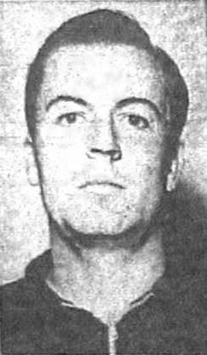
Having met Tony a few times now, he told me a few years back that his most enjoyable time in football was at Epsom. Looking back at 1966/67, it’s hard to see where the enjoyment came from, as we fell from ninth to twelfth, although we did hand eventual Champions Eastbourne United their first of what would be only two defeats that season by five goals to two, and drawing the return match 0-0.

In fairness to Williams we had picked up just two draws from the opening seven league matches and so he was already up against it, but clearly tried his best as shown on 15th October 1966 when he scored four times yet still found himself on the losing side as Ware won 5-4 at West Street. To this day, Williams remains the last player to score a hat trick for our club and still finish on the losing side!

However, the most concerning aspect of our season was the indefinite suspension levied by the Surrey F.A. for disciplinary issues.

This was incredibly harsh as we had picked up one red card all season to that point and this had come before Williams took over, but there had been issues in previous seasons and a warning had been issued in June 1967 which Bob Bell had, maybe understandably not advertised. Interestingly the red card I refer to came in September while our suspension came in December which tells you that the administrative processes there were, shall we say, equally frustrating back then!

An appeal was held at Plough Lane, Wimbledon, led by Chairman George Tarran which was successful. As a result we were suspended for just seven days and our next match at Wingate on 17th December 1966 was described, using the Jewish club as a reference point, as rabbis against vicars as the match was so clean! There was hardly a foul in the match, and the cynic would argue that it was without a tackle of any sort either as Epsom triumphed by the incredible scoreline of seven goals to five!

Another wild game occurred on 21st January 1967 as Epsom defeated Ruislip Manor 6-5 but a 6-0

defeat at Herne Bay indicated that there was still much work to do. A 6-3 win over Windsor & Eton in April helped fuel the excitement for the next season, but it wasn’t to be. Williams said he would rejoin but then left for Dulwich Hamlet during the summer. He would go on to make his mark in another area of football entirely, teaming up with the visionary Jimmy Hill and cigarette manufacturers Rothmans to create the first ever Football Yearbook in 1970. A Non-League version followed in 1978 and Tony Williams Publishing was also responsible for Two Legs Not Four, my club history book that was released in 2007. Nowadays retired and living in Somerset, Tony is 78 and his son Mike does most of the work. However, he still takes an interest and was also present at our F.A. Vase match against Wellington, down in his neck of the woods a few years back.

Another well-known local footballer followed him into the role of Epsom Player / Manager. His name was Dave Fillery. He had played a match for us once previously when he was one of the Tooting & Mitcham United “guests” in our ill-fated end of season match with Hertford Town in May 1965 but had previously played for Maidstone United, Walton & Hersham and Carshalton Athletic along with his brother Ray with a fair bit of success before graduating to the Isthmian League club. As with Williams before he was looking at getting into Management and joined after a brief spell at Redhill. He was an accountant by profession and was 29 at the time of his appointment.

He had a fortunate start to his Managerial career by picking up a local player of some talent in 17 year old Chris Kelly. His uncle Bernard Smith had been a Youth and first team player in the fifties and recommended that he go there after leaving local club Epsom Methodists in the Sutton & District League and wold be ever present all season, going on of course to have a famous career in particular at Leatherhead. Despite this, results were patchy and it was only the form of Eastbourne and Wingate who were well adrift that enabled us to finish third from bottom of the league. Worse still, Fillery injured ligaments in March 1968 and was out for a few games, one of which was the Athenian League Division Two Cup Final first leg against Edmonton which was lost 0-3. Not that it really mattered though as Edmonton then won the second leg 4-0 too to clinch the trophy 7-0 on aggregate!

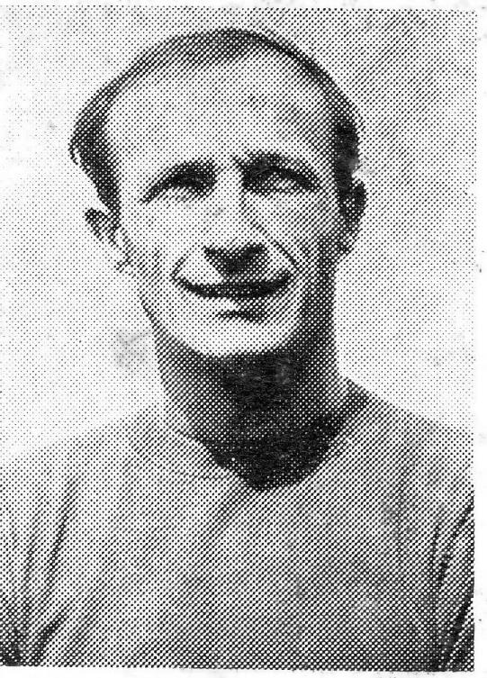
The 1968/69 season was no better with fourteenth place out of sixteen being the end result once again. Fillery even picked up the first booking of his career at Worthing on Boxing Day 1968 when we were beaten 5-1 and talented Dave Legrice was sent off. That match was followed by a grim 0-6 home defeat to Boreham Wood and although we won 3-2 at Uxbridge in our next match, we would win only two of the remaining twenty-one matches and at the end of the season Fillery resigned due to the age old “work commitments” excuse and we were on the lookout for a new man in charge once again.

Match and Ball Sponsorships – 2018/19
Opponent | Date | Match Sponsor | Ball Sponsor
Chessington & Hook Utd | 21/08/18 | Club President - Stella Lamont
Beckenham Town (FAC) | 28/08/18 | Building Shop Ltd
Cove | 08/09/18 | EEFC Management Committee
Tooting Bec | 15/09/18 | Building Shop Ltd
Bagshot (LC) | 25/09/18
Sheerwater | 06/10/18 | Paul Merritt
Knaphill U23  (Surrey Premier Cup) | 23/10/18 | Jack Jarman
Frimley Green | 03/11/18 | Our Chairman’s Grandchildren – George, Joseph, Ezara and Inaya
Sandhurst Town (LD1C) | 06/11/18 | Richard Lambert
Kensington Borough | 17/11/18 | Jeff & Arnold Pye
Dorkinian (SPC) | 20/11/18
Dorking Wanderers Res | 27/11/18
Godalming Town | 01/12/18 | John Bonner
Bedfont & Feltham | 08/12/18
Eversley & California | 29/12/18
Ash United | 12/01/19
Godalming Town (LC) | 15/01/19
Bagshot | 19/01/19
Farnham Town | 02/02/19
British Airways | 16/02/19
AC London | 02/03/19
FC Deportivo Galicia | 12/03/19
Fleet Spurs | 06/04/19
Sandhurst Town | 20/04/19 | Club President - Stella Lamont
Match sponsorship costs just £60.00!

Sponsorship includes:

Admission, programmes and hospitality for three people.

A full page advert in the programme and mascot for the day (if required).

If you are interested, just speak to a Committee Member,
or drop me an email at: richard.c.lambert@gmail.com

Combined Counties League Premier Division
Opponents All-time Records
incl Saturday  22nd December | P | W | D | L | F | A | PPG | GD | Best  Win | Worst  Loss
AC London | 1 | 1 | 0 | 0 | 6 | 0 | 3.00 | +6 | 6-0 | -
Bagshot | 2 | 2 | 0 | 0 | 4 | 0 | 3.00 | +4 | 3-0 | -
FC Deportivo Galicia | 1 | 1 | 0 | 0 | 3 | 0 | 3.00 | +3 | 3-0 | -
Tooting Bec | 1 | 1 | 0 | 0 | 3 | 1 | 3.00 | +2 | 3-1 | -
Fleet Spurs | 1 | 1 | 0 | 0 | 3 | 2 | 3.00 | +1 | 3-2 | -
Frimley Green | 11 | 9 | 1 | 1 | 35 | 5 | 2.55 | +30 | 7-1 | 0-1
Bedfont & Feltham | 3 | 2 | 1 | 0 | 17 | 7 | 2.33 | +10 | 9-2 | -
Godalming Town | 4 | 3 | 0 | 1 | 7 | 7 | 2.25 | 0 | 3-2 | 0-3
Ash United | 20 | 11 | 3 | 6 | 50 | 32 | 1.80 | +18 | 6-0 | 0-3
Farnham Town | 18 | 9 | 4 | 5 | 31 | 29 | 1.72 | +2 | 3-0 | 1-4
Cove | 35 | 16 | 9 | 10 | 78 | 57 | 1.63 | +21 | 7-0 | 1-6
Chessington & Hook | 30 | 13 | 9 | 8 | 63 | 45 | 1.60 | +18 | 6-0 | 1-3
Sheerwater | 5 | 2 | 2 | 1 | 10 | 5 | 1.60 | +5 | 3-0 | 2-3
Dorking Wanderers Res | 2 | 1 | 0 | 1 | 6 | 5 | 1.50 | +1 | 3-0 | 3-5
Sandhurst Town | 16 | 7 | 0 | 9 | 28 | 28 | 1.31 | 0 | 4-0 | 1-3
Kensington Borough | 1 | 0 | 1 | 0 | 1 | 1 | 1.00 | 0 | - | -
British Airways | 1 | 0 | 0 | 1 | 2 | 3 | 0.00 | -1 | - | 2-3
Eversley & California | 1 | 0 | 0 | 1 | 1 | 2 | 0.00 | -1 | - | 1-2

Combined Counties League – Division One
Saturday, 29th December 2018 - Kick-off 3.00 p.m.
Epsom and Ewell  (Royal Blue & White hoops) | V |  | Eversley & California  (All Red )
Squad | NUMBERS |  | Squad
Conor Young |  |  | Charlie Lusty
Louis Chin |  |  | Charlie York
Luke Elgar |  |  | Ali Dickie
Reisse Griffin |  |  | Josh Smith
Lloyd Connelly |  |  | Ryan Whyte
Jamie Watts |  |  | Connor Allston
Steve Betancourt |  |  | Marcus Guest
David Jones |  |  | Brad Brown
Adam Heagney |  |  | Mo Davis
Todd Murphy |  |  | Jamie McCarthy
Ryan Sullivan |  |  | Aron Rowland
Liam Roberts |  |  | Sam Wood
© Scott Murphy |  |  | Adam Edwards
Scott Elgar |  |  | Brandon Blair
Elliott Thompson |  |  | Steve Peacock
Bobby Bennett |  |  | Clive Akem-Che
Rob Hendry |  |  | Leon Hewitt
Roy Gayle |  |  | Scott Ransom
Olly Martinez |  |  | Jack Kittlesen
Germaine Jeannoel |  |  | Owen Powell
Hakim Griffiths |  |  | Andrew Pearson
Joshua Caulcrick
Taryn Smith
Simon Funnell | MANAGER |  | Ross Allston
Matt Drew | ASST MANAGER |  | Ryan Nevard / Sam Wilson
Sam Morgan | COACHES |  | Dan Snook / Nick Pyne
 | PHYSIO
REFEREE: A.Merchant
ASSISTANTS: R van Niekerk, M.Stevens

OUR NEXT VISITORS TO HIGH ROAD
Ash United
Combined Counties League – Division One
Saturday, 12th January 2019 – 3.00 pm

